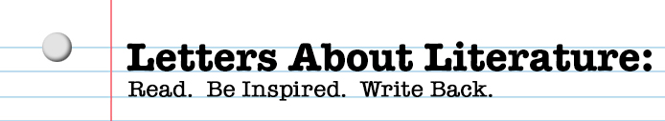
Write a letter to the author of your text explaining how reading this book has affected you. The content of this letter is personal, so topics will vary. You may choose to compare a personal experience to the content of the book, explain how you have been challenged or inspired by this book to learn something or do something differently, ask questions of the author and describe why the questions matter to you, or any number of other options. Be authentic, sincere, and truthful. Organize your thoughts carefully into paragraphs, but do not treat this assignment as an essay. Revise your writing to elevate your diction, but maintain your own personality and voice. Punctuate your sentences correctly so that your meaning is clear, but feel free to use punctuation outside of the context of grammar rules to show tone and expression.
For inspiration, see examples of National Winners (grades 9-12) at the Library of Congress’s website: http://read.gov/letters/contests/winners/2015/index.html.

 | Rubric
Level 5  (90-100) | Your letter is honest and personal, with a clear message and topic that is fully explained and developed. Your writing is organized thoughtfully and stays focused on your overall topic but does not read like an essay. Even so, you have a clear introduction and conclusion and use transitions from point to point and paragraph to paragraph. Your message is enhanced by how you say it. Eloquent sentences and elevated diction reveal your emotions and are persuasive. Grammar and punctuation are both correct and contribute to the overall voice and tone.
Level 4  (80-89) | Your letter is honest and personal, with an obvious message and a topic that is explained and developed. Your writing is mostly organized and focused with a clear beginning, middle, and end. You frequently use transitions to connect points and paragraphs. Your sentences are varied in structure and have above-average vocabulary. Your grammar and punctuation help keep your meaning clear.
Level 3  (70-79) | Your letter feels more like an academic exercise than honest communication from you to an author. Your writing is generally organized and but may not have a clear message or focus. Your sentence structure and word choices communicate well but do not necessarily have a strong tone. Grammar and punctuation are generally correct and do not prevent the reader from understanding your message.
Level 2  (60-69) | Your letter fails to demonstrate skill in three or more of the following areas: authenticity, message, focus, organization, sentence structure, grammar, or punctuation.
Level 1  (50-59) | Your letter fails to demonstrate skill in a majority of these areas: authenticity, message, focus, organization, sentence structure, grammar, or punctuation.

